Kinematics Review Quiz Multiple Choice Questions

1. Which of the following are VECTOR quantities?
I. position II. speed III. displacement IV. velocity
a. I and III only d. II, III and IV only
b. III and IV only e. I, III and IV only
c. I and IV only

2. Two hikers set out from the same spot and arrive at the same destination but they take different routes. Which of the following quantities must be the same for both hikers?
a. | distance | d. | average speed
b. | displacement | e. | acceleration
c. | average velocity

3. Which of the following graph(s) does(do) NOT represent uniform motion?
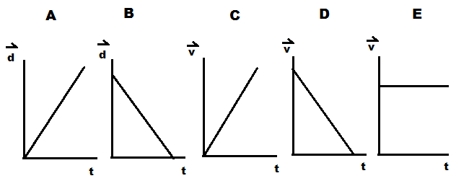

a. | A,B,C and D | d. | A and B
b. | B only | e. | C and D
c. | E only

4. The slope of a line drawn tangent to a curved position-time graph represents
a. | displacement | d. | acceleration
b. | instantaneous velocity | e. | distance
c. | average velocity

5. An object is travelling west and slowing down. The directions associated with the
object’s velocity and acceleration, respectively, are:
a. [W], [W] b. [W], [S] c. [W], [E] d. [E], [W] e. [E], [S]

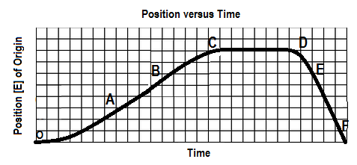
6. The graph below shows a position-time graph

Over which interval is the object moving west and speeding up?
a. OA b. BC c.CD d. DE e.EF

7. The area under a velocity-time graph represents
a. | displacement | d. | instantaneous velocity
b. | acceleration | e. | average velocity
c. | change in velocity

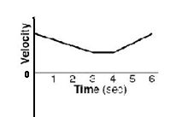
8. A velocity-time graph is shown at right. Which of following best
describes the object’s motion? The object

a. moves backward at a constant velocity, stops, then moves forward at constant velocity.
b. moves forward at a constant velocity, stops, then moves backward at constant velocity
c. slows down uniformly as it moves backward, stops, then speeds up uniformly as it moves forward
d. slows down uniformly as it moves forward, continues at a constant velocity forward, then speeds up
uniformly as it continues to move forward
e. slows down uniformly as it moves backward, continues at a constant velocity backward, then speeds
up uniformly as it moves forward

SPH4U0-Sept. 11/2013 Kinematics Review Quest-VERSION A Name:_________________
Total: _________/37 marks [K/U]
Useful Equations and Constants:

Acceleration due to gravity on Earth: 9.80 m/s² [down]

v_{av} =ΔΔ a = ΔΔ = Δ Δd= ½ (v₁+v₂) Δt Δd=v₂ Δt – ½ a (Δt)²

Δd=v₁ Δt + ½ a (Δt)² Δd = $\frac{v22-v12}{2a}$ $x=\frac{-b±\sqrt{b^{2}-4ac}}{2a}$

Part A: Multiple Choice Answers [ 8 marks]:
Write the letter representing the best answer for each question in the table below:
1 | 2 | 3 | 4 | 5 | 6 | 7 | 8

Part B: Short Answer [ 4 marks]:

1. With the aid of two specific examples, explain the difference between uniform and non-uniform
motion. [2]

2. While out training for cross country, you notice that your GPS watch records your average velocity as
“0.0 km/h” after you ran 10 laps around the track. Is your watch correct? Explain. [2]

Part C: Graph Analysis [8 marks]

1. The motion of a train engine moving along a straight track in a railyard is shown on the velocity-time
graph below.
i) Draw the corresponding acceleration-tine graph for the train. [3]
ii) Assuming that the train starts at the station (origin), draw the corresponding
position-time graph. [5]

Position-Time Graph:

Velocity-Time Graph:
8

4

0

-4

-8

V
(m/s)

[E]
Time
(s)
 | 1.0 |  | 2.0 |  | 3.0 |  | 4.0 |  | 5.0 |  | 6.0 |  | 7.0 |  | 8.0 |  | 9.0 |  | 10.0

Acceleration-Time Graph:

Part D: Problem Solving [ 16 marks]

1. Lazee Cat is sitting at rest when a bird flies by with a constant velocity of 8.00 m/s [Forward].
Lazee Cat immediately takes off in hot pursuit accelerating uniformly from rest at 1.25 m/s²
Forward]. Determine the time and displacement required for Lazee Cat to catch the bird. [6]
( Note: No birds were harmed in the making of this test. Lazee Cat practices catch and release!)

Graph Analysis Calculations:

2. A magician tosses a coin straight up into the air with an initial velocity of 7.00 m/s [up]. The coin rises up and strikes an overhead light located 2.00 m above the magician’s head.
a) Find the coin's velocity just as it hits the light. [3]
b) Find the time the coin was in the air. [3]

3. A truck driver turns onto Bovaird Avenue and travels at a constant velocity of 60.0 km/h [West] for 10.0 seconds. As the truck enters a construction zone, the driver accelerates uniformly for 2.0 seconds to reach a final velocity of 40.0 km/h [West]. She then proceeds to travel at this new velocity, reaching the end of the construction zone after another 10.0 seconds.
a) Sketch the velocity-time and position-time graphs for the motion of the car assuming the origin is the point at which the truck turned onto Bovaird. (Although no scales are required, the time scales of the two graphs should correspond). [3d]

$\vec{v}$
[West]

$$\overset{→}{d}$$
[West]

b) Briefly explain the analysis you would perform to find the total displacement of the car over the trip described. (No calculations are required). [2]

